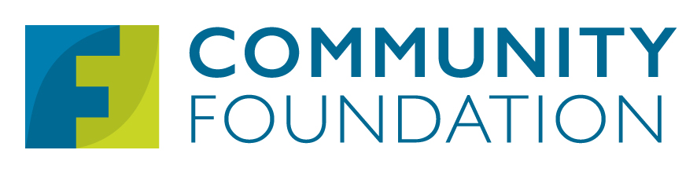

Your Logo Here

For Immediate Release
<Date>

Community Foundation Contact: <Your Organization Name> Contact:
Kayla Ellis, Public Relations Manager <Contact Name, Contact Title>
kellis@foundationhoc.org <Contact Email Address>
315-735-8212 ext. 3740 <Contact Phone Number>

Headline Goes Here

UTICA, NY – <Your organization’s name> and the Community Foundation of Herkimer & Oneida Counties have recently partnered to make an impact in the community that will help to <describe what the impact is and who will benefit>.

The $<0,000> investment from the <fund name(s) (as noted in award letter)> of the Community Foundation will help <your non-profit organization> to <what the investment is being used for>. <In a few sentences, describe what the outcomes will be and why it’s important to our community.>

<Consider inserting a short quote from a representative of your organization discussing the importance of this project.>

<Consider asking the Community Foundation to provide a short quote from a representative on the benefit that project will have for the community.>

<Finish with a sentence or two about your organization, including its mission and contact information.>

Founded in 1952, The Community Foundation of Herkimer and Oneida Counties envisions a vibrant region with opportunity for all. In fulfillment of its “Engage. Invest. Lead” mission, The Community Foundation has transformed decades of donor generosity into $100 million invested in social impact initiatives, collaborative leadership, grantmaking and scholarships. Find out more at foundationhoc.org or call 315-735-8212.

###

